Polynomial Functions

- Create a polynomial that has multiplicity 5 and exactly one real zero.

- Create a polynomial that has exactly two zeros which are complex conjugates.

- F(x) is a polynomial function of degree 4 whose coefficients are real numbers, and you know three of its zeros are 5, 1+2i, 1-2i. Could the remaining zero be imaginary; why or why not?

.
- Find the remainder when 2x¹⁰⁰− 17x³⁴⁸ +6x +19 is divided by x + 2.

- Is x − 3 a factor of x²⁶−3x⁴⁰+ x⁷ ?

- Create a polynomial that has the following characteristics:
Crosses the x-axis at 8 and -2, Touches the x-axis at 3 and is above the x-axis between -2 and 3.

- A cardboard box has a square base with each edge of the base having length x inches as shown in the figure. The total length of all 12 edges of the box is 132 in.
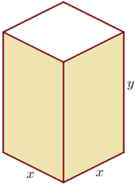
- Write an expression for the volume of the box in terms of x

- Graph your function from part a and use your calculator to estimate the dimensions that would yield maximum area.

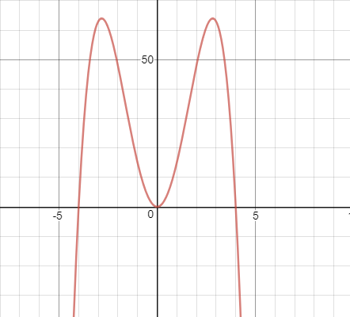
- Is the degree of the polynomial represented in this graph even or odd?

- Is the leading coefficient positive or negative and why??

- Is the function even, odd, or neither and why?

- Is x² a factor of the polynomial?

- What is the minimum degree of the polynomial?

- Formulate a polynomial whose graph could look like the one shown.

