When income tax in the U.S. is calculated, everyone pays the same percent tax on the income up to a certain threshold. As income increases, you pay additional taxes on the amount above that threshold. For example, in 2018, every person filing income tax as a single filer pays 10% on the first $9,525 earned. Those who earned more than $9,525, but not more than $38,700 paid 10% on the first $9,325 and 12% on the amount above $38,700. These percentages are called “marginal tax rates” and are summarized in the table. This table is used for single filers (those who file their taxes alone, not jointly with a spouse).
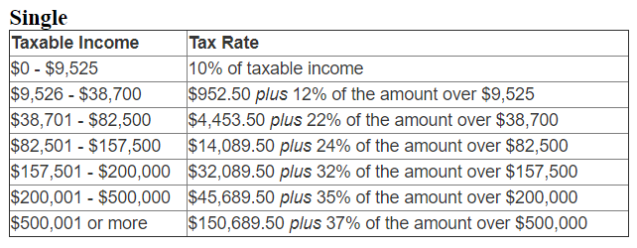
Table Source: “2018 Federal Tax Rates, Personal Exemptions, & Standard Deductions: IRS Tax Brackets & Deduction Amounts for Tax Year 2018.” IRS. https://www.irs.com/articles/2018-federal-tax-rates-personal-exemptions-and-standard-deductions. Accessed 29 Oct. 2018.

Illustration from: “2018 Federal Income Tax Brackets and New Tax Rates.” Nerd Wallet. Tina Orem. https://www.nerdwallet.com/blog/taxes/federal-income-tax-brackets/. Accessed 29 Oct. 2018.

Example: Calculate income tax for taxable income $50,000
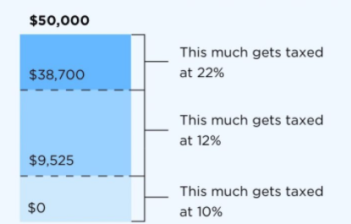

Using the table as a guide, calculate the following:

- For each hypothetical taxable income, calculate the amount of tax owed by a single filer in 2018. Then calculate the overall percent of their income paid in income tax. Use the space below and/or scratch paper to show your work.

 |  | Income Tax Paid: | Percent of Total Income:
a. | $32,000
b. | $80,000
c. | $250,000
d. | $550,000

- A friend of yours reads the table and observes that the highest-income earners pay 37% of their total income in taxes. Is this accurate? Explain why or why not. Feel free to use an example to demonstrate, or just explain in words.

- A politician suggests taxing the wealthy at a marginal tax rate of 70% on taxable income over $5,000,000. Does this mean that people who make more than $5,000,000 will pay 70% of their total income in taxes? What additional information would you want to know before you decided whether you agreed with her plan?

- A friend of yours reads the table and concludes that, if you get a raise at work, you might actually take home less money (in dollars) than you did before, since the government is taking a greater percent of your income. Is this accurate? Explain why or why not. Feel free to use an example to demonstrate, or just explain in words.

